Laboratorul 6

Chiș Cosmin- Andrei

Exercitiul 0:

-site: <https://www.w3schools.com/>

a)

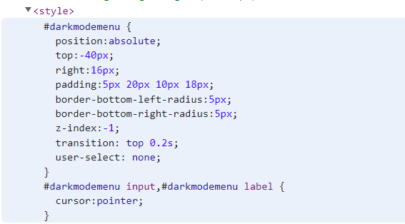

b) 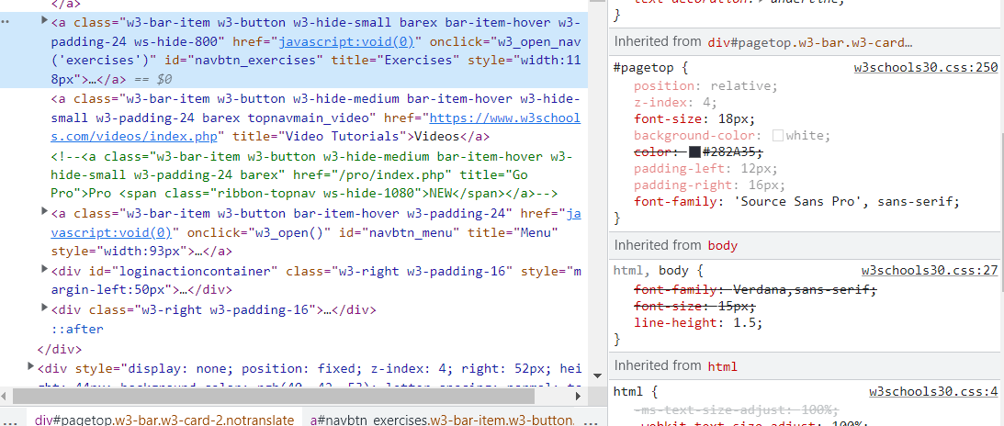

c)

